Special Arrival Information for Carlton Hill Tenants
Arrivals by car - Saturday 15th & Sun 16th September 11am - 4pm
Carlton Hill has a fantastic city centre location, but this does mean that parking has to be limited to 20 minute drop-off on arrivals weekend. There are 200 students moving in to Carlton Hill on this weekend and we wish to ensure everyone can move in with ease.
- The driver of the vehicle will be required to stay with the vehicle
- The driver will be required to move it off the site immediately after dropping off bulky or heavy items.
- The unloading time is 20 minutes.
- Please do not bring large vans to site or multiple cars and visitors
- We would really appreciate it if parents and guardians can plan to take home moving in boxes and rubbish so the waste bins are free for the normal day-to-day operation of the building.
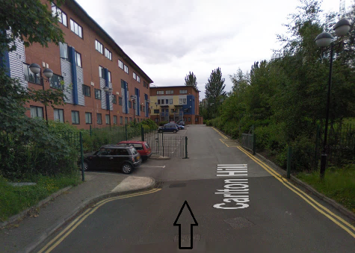
Driving to Woodhouse Lane/Leeds Arena Car Park from Carlton Hill - 5 minute drive

https://www.leeds.gov.uk/parking-roads-and-travel/parking/city-centre-car-parks/woodhouse-lane-car-park
Use this link for directions https://goo.gl/s2S5rc

Walking back to Carlton Hill from Woodhouse Lane Carpark - 3 minute

